The University of Azad Jammu and Kashmir, Muzaffarabad

Name :Alishba Zakir
Roll No: 2024-SE-02
Course: Computer Networks
Course Code: SE-2203
Lab# Open ended
Submitted To: Engr. Dr. Asma Javaid
Submitted By: Alishba Zakir
Date : May, 2026

Department Of Software Engineering
- Objective of the Lab
The objective of this lab is to design and configure a small network using switches and a router, assign IP addresses to devices, and verify communication between different networks using proper configuration and testing methods.
- Full configuration:
The show running-config command displays all switch settings to verify correct configuration.
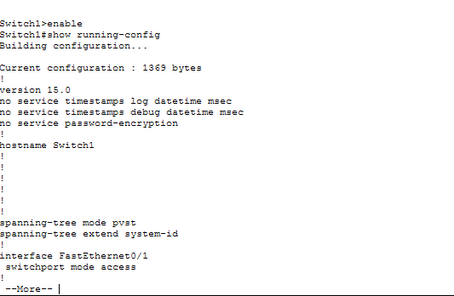
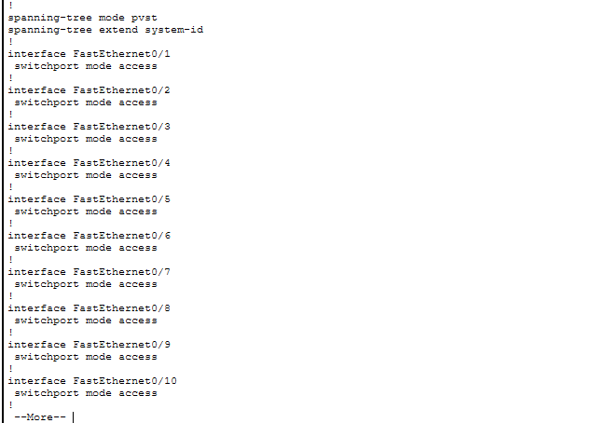
- Port Status
The show interfaces status command is used to check whether switch ports are active and connected.

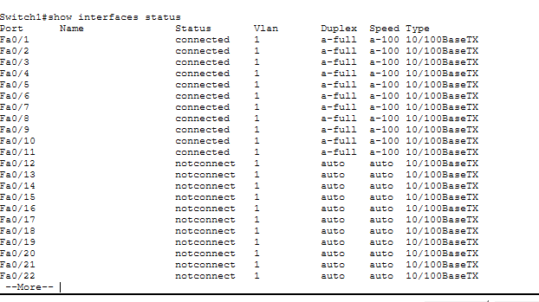
- IP information:
The show IP interface brief command displays IP addresses and the status of switch interfaces.
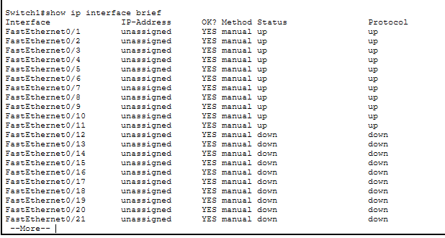
- Check specific port
The show interfaces fa0/11 command is used to check the status and details of a specific switch port.

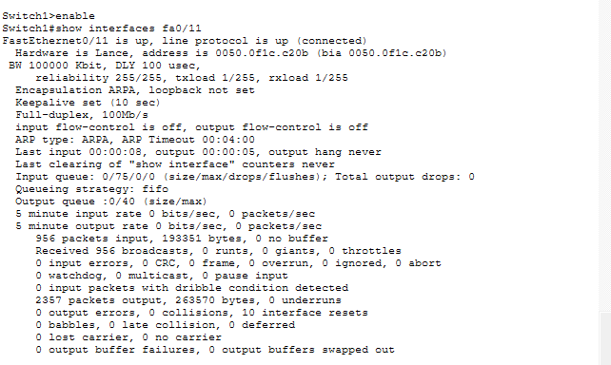

- Communication between pcs of same switch
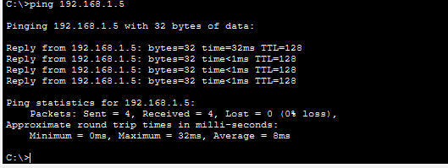
- Communication between pcs of different switches
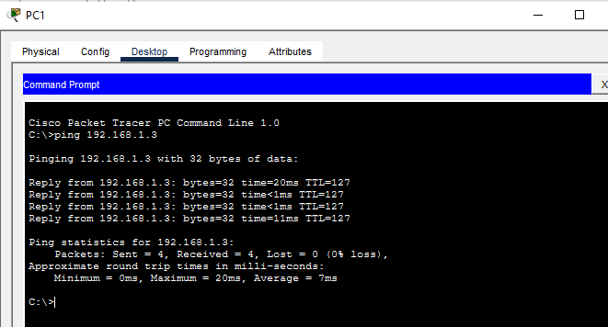
- Communication between pc and printer of same switch
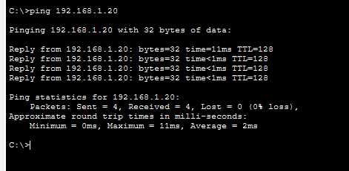
- Communication between pcs and printer of different switch
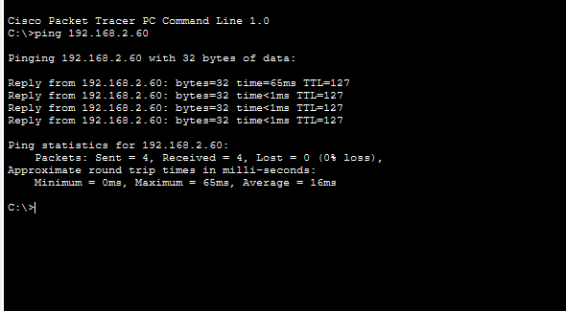
- Communication between pc and server of same switch
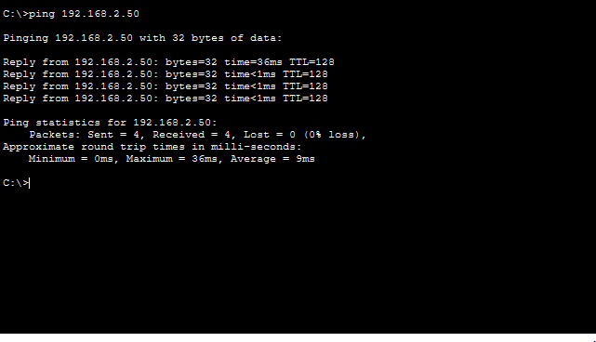
- Communication between server and pc of different switch
